**Web Programming**

Lab - 5

HTML – Semantic tags, Frames & Media Elements

Name: Sushen Grover

Reg No: 23BCE1728

Slot: L11+L12+L31+L32

Class No: CH2024250502774

Course Code: BCSE203E

Faculty: Dr. L.M. Jenila Livingston

Question 1:

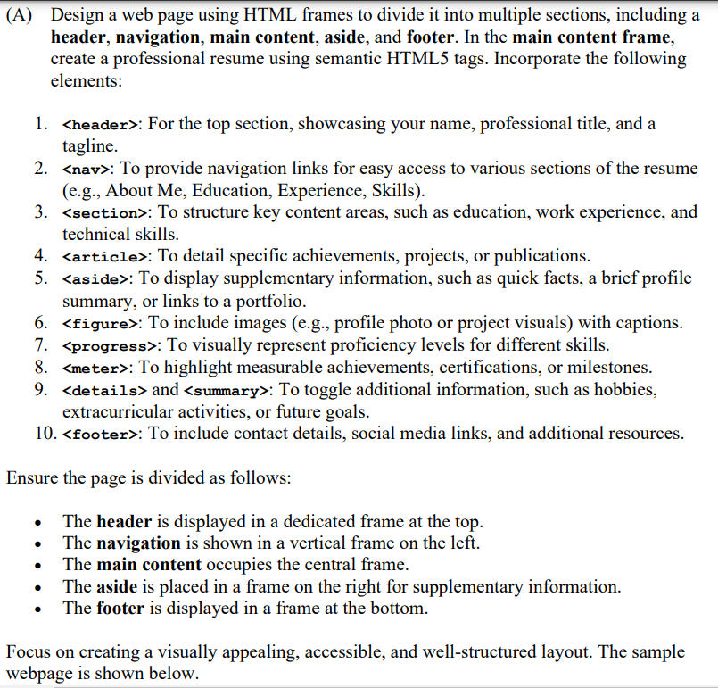

Code:

**ex1.html**

<!DOCTYPE html>

<html lang="en">

<head>

    <meta charset="UTF-8">

    <meta name="viewport" content="width=device-width, initial-scale=1.0">

    <title>23BCE1728</title>

</head>

<*frameset* rows="15%,*,20%" *border*="2">

    <*frame* src="header.html">

    <*frameset* cols="15%,65%,20%" *border*="2">

        <*frame* src="navigation.html">

        <*frame* src="main_content.html" name="main_content">

        <*frame* src="aside.html">

    </*frameset*>

    <*frame* src="footer.html">

</*frameset*>

</html>

**header.html**

<!DOCTYPE html>

<html lang="en">

<head>

    <meta charset="UTF-8">

    <meta name="viewport" content="width=device-width, initial-scale=1.0">

    <title>Document</title>

</head>

<body style="background-color: rgb(206, 205, 205);">

    <header>

        <h1 *align*="center">My Professional Resume</h1>

    </header>

</body>

</html>

**navigation.html**

<!DOCTYPE html>

<html lang="en">

<head>

    <meta charset="UTF-8">

    <meta name="viewport" content="width=device-width, initial-scale=1.0">

    <title>Document</title>

</head>

<body>

    <nav>

        <a href="main_content.html#about_me" target="main_content">About me</a><br>

        <a href="main_content.html#education" target="main_content">Education</a><br>

        <a href="main_content.html#experience" target="main_content">Experience</a><br>

        <a href="main_content.html#skills" target="main_content">Skills</a><br>

        <a href="ex2.html" target="main_content">Media</a><br>

    </nav>

</body>

</html>

**main_content.html**

<!DOCTYPE html>

<html lang="en">

<head>

    <meta charset="UTF-8">

    <meta name="viewport" content="width=device-width, initial-scale=1.0">

    <title>Document</title>

</head>

<body>

    <article>

        <h3 id="about_me">About Me</h3>

        <p *align*="justify">I am a Computer Science and Engineering student at VIT Chennai with a passion for problem-solving and creating efficient and impactful solutions. I have a strong foundation in Data Structures and Algorithms and I am skilled in programming languages like Python, Java, C, and C++. I also have experience in data analytics, using tools such as MySQL, Spreadsheets, Tableau, and R to uncover meaningful insights and support data-driven decision-making. I am currently expanding my knowledge in web development tools like HTML, CSS and JavaScript.</p>

        <p *align*="justify">I take on challenges with a calm, focused mindset and always prioritize sincerity and precision in my work. With a forward-thinking approach, I adapt quickly to demanding situations and consistently aim to achieve excellence in everything I do.</p>

        <figure>

            <*center*>

                <img src="pp.jpg" width="130" alt="">

            </*center*>

        </figure>

        <h3 id="education">Education</h3>

        <ul>

            <li>

                <b>Vellore Institute of Technology</b><br>

                Bachelor of Engineering - BE, Computer Science<br>

                2023 - 2027<br>

                CGPA: 9.35

                <meter value="9.35" min="0" max="10">CGPA Meter</meter>

            </li>

            <li>

                <b>Holy Heart Day Boarding Public School, Fazilka</b><br>

                Senior Secondary Education <br>

                Grade: 88% (Class XII)

                <meter value="88" min="0" max="100">Marks Meter</meter>

            </li>

            <li>

                <b>Sacred Heart Convent School, Fazilka</b><br>

                High School Education <br>

                Grade: 94% (Class X)

                <meter value="94" min="0" max="100">Marks Meter</meter>

            </li>

        </ul>

        <h3 id="experience">Experience</h3>

        <ul>

            <li>

                <b>NexSeed Club, VITC</b><br>

                Design Team Member<br>

            </li>

            <li>

                <b>VIT Finance and Management Club</b><br>

                Content & Design Team Member<br>

            </li>

            <li>

                <b>PlaceXP Club, VITC</b><br>

                Creative Team Member<br>

            </li>

        </ul>

        <h3 id="skills">Skills</h3>

        <details>

            <summary>Web Development</summary>

            <progress value="80" max="100"></progress>

            <ul>

                <li>HTML</li>

                <li>CSS</li>

                <li>JavaScript</li>

            </ul>

        </details>

        <details>

            <summary>Data Analytics</summary>

            <progress value="80" max="100"></progress>

            <ul>

                <li>MySQL</li>

                <li>Spreadsheets</li>

                <li>Tableau</li>

                <li>Google BigQuery</li>

                <li>R Programming Language</li>

            </ul>

        </details>

        <details>

            <summary>

                Coding Languages

            </summary>

            <progress value="80" max="100"></progress>

            <ul>

                <li>Java</li>

                <li>Python</li>

                <li>C</li>

                <li>C++</li>

            </ul>

        </details>

    </article>

</body>

</html>

**aside.html**

<!DOCTYPE html>

<html lang="en">

<head>

    <meta charset="UTF-8">

    <meta name="viewport" content="width=device-width, initial-scale=1.0">

    <title>Document</title>

</head>

<body>

    <aside>

        <h3>Quick Facts</h3>

        <ul>

            <li>Proficient in English, Hindi & Punjabi.</li>

            <li>I value Sincerity & Precision in my Work.</li>

            <li>I foster collaboration and resolves conflicts with composure.</li>

            <li>I organize and prioritize tasks to meet deadlines.</li>

        </ul>

    </aside>

</body>

</html>

**footer.html**

<!DOCTYPE html>

<html lang="en">

<head>

    <meta charset="UTF-8">

    <meta name="viewport" content="width=device-width, initial-scale=1.0">

    <title>Document</title>

</head>

<body *align*="center" style="background-color: rgb(214, 214, 214);">

    <footer>

        <h3>Contact Details</h3>

        <a href="https://www.linkedin.com/in/sushen-grover-2b3314290/">Linkedin</a>

        |

        <a href="https://www.instagram.com/sushen.grover/">Instagram</a>

        |

        <a href="tel:+917009367016">70093-67016</a>

        |

        <a href="mailto:groversushen@gmail.com">groversushen@gmail.com</a>

        <p>&copy; 2025 My Website</p>

    </footer>

</body>

</html>

Output:

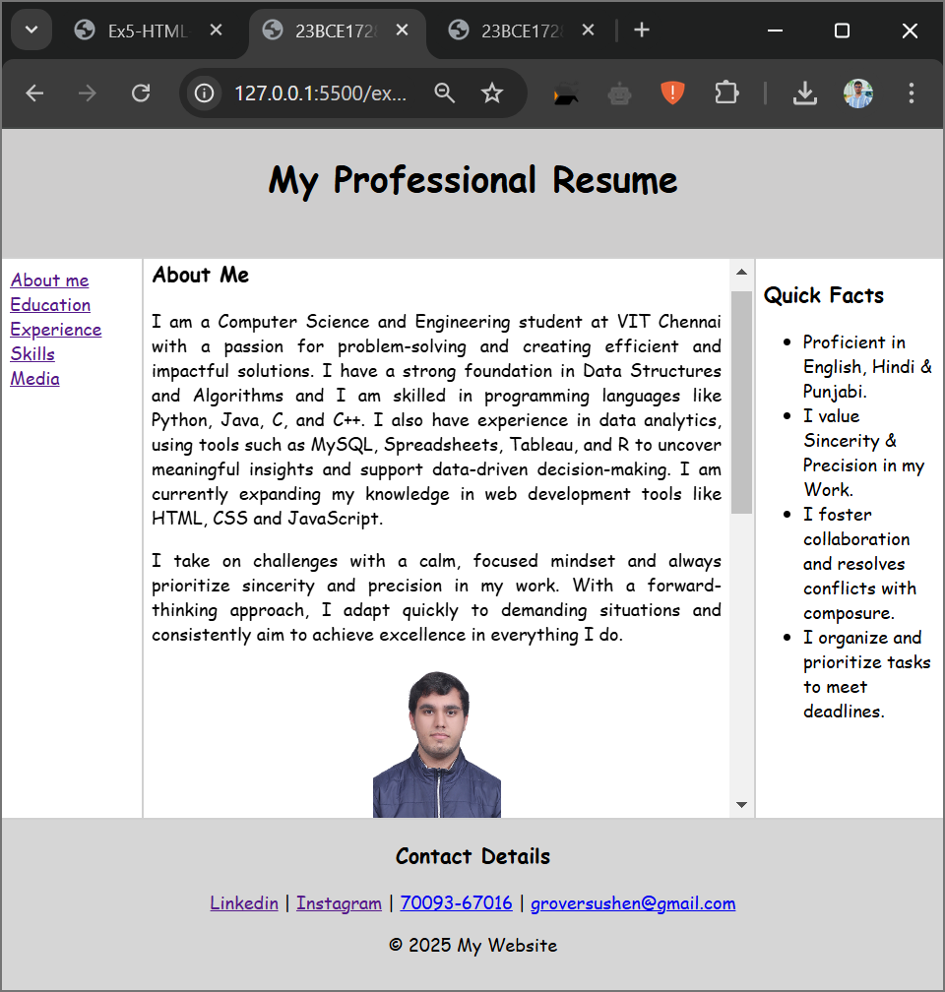

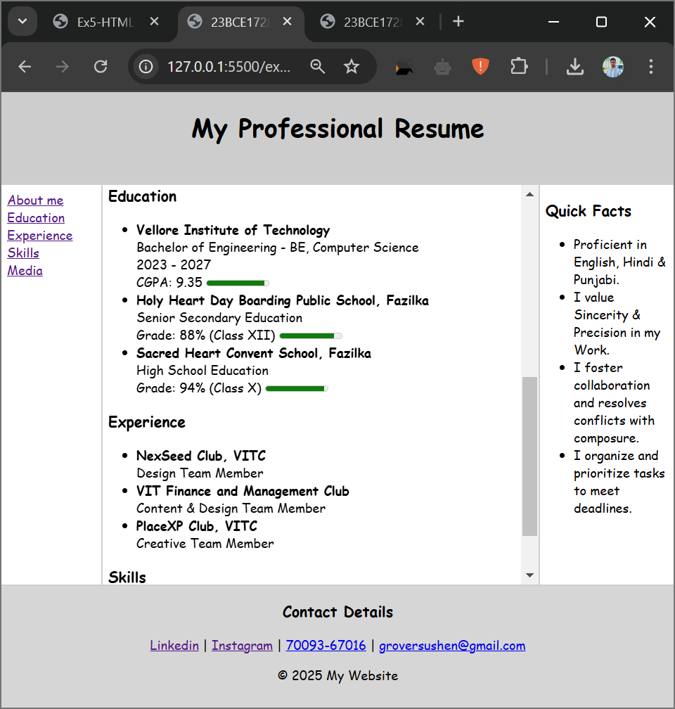

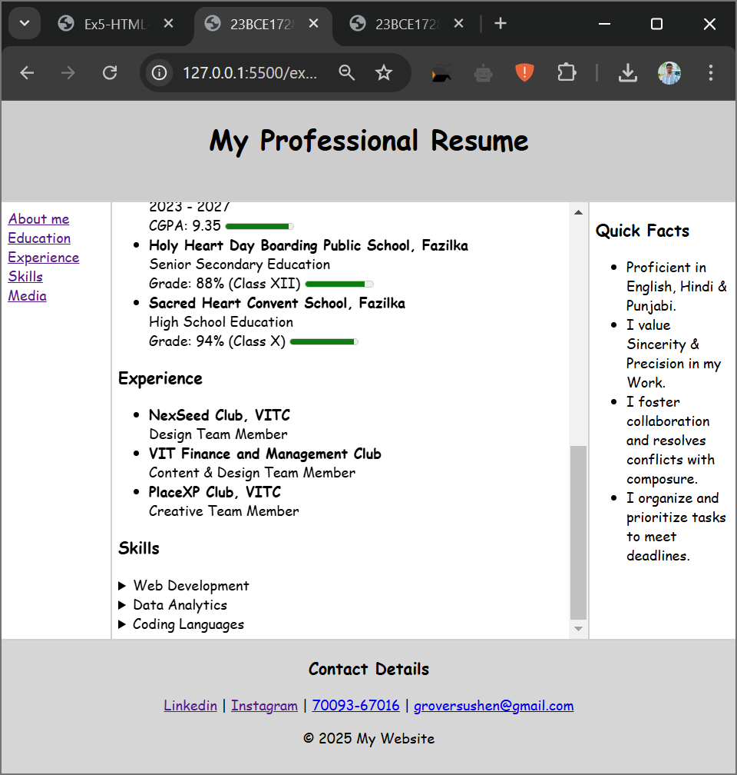

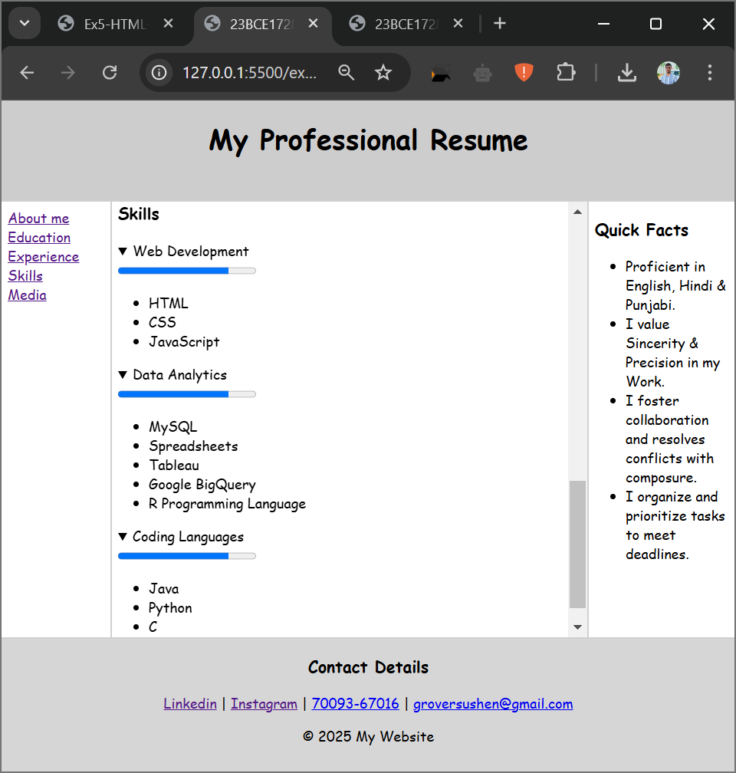

Question 2:

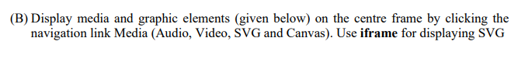

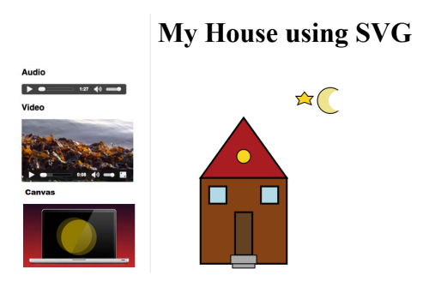

Code:

ex2.html

<!DOCTYPE html>

<html lang="en">

<head>

    <meta charset="UTF-8">

    <meta name="viewport" content="width=device-width, initial-scale=1.0">

    <title>23BCE1728</title>

</head>

<*frameset* cols="30%,70%" *border*="2">

    <*frame* src="media.html">

    <*frame* src="svg.html">

</*frameset*>

</html>

media.html

<!DOCTYPE html>

<html lang="en">

<head>

    <meta charset="UTF-8">

    <meta name="viewport" content="width=device-width, initial-scale=1.0">

    <title>Document</title>

</head>

<body>

    <h3>Audio</h3><br>

    <audio src="Winning Speech.mp3" controls></audio>

    <h3>Video</h3><br>

    <video src="Happy Ganesh Chaturthi (Nexseed Club).mp4" height="300" autoplay controls></video>

    <h3>Canvas</h3><br>

    <canvas width="400" height="200" style="border:1px solid #000" id="myCanvas"></canvas>

    <script>

        const canvas = document.getElementById('myCanvas');

        const ctx = canvas.getContext('2d');

        //rectangle with a gradient

        const gradient = ctx.createLinearGradient(0, 0, canvas.width, 0);

        gradient.addColorStop(0, "red");

        gradient.addColorStop(1, "blue");

        ctx.fillStyle = gradient;

        ctx.fillRect(0, 0, canvas.width, canvas.height / 2);

        //circle

        ctx.beginPath();

        ctx.arc(200, 150, 50, 0, 2 * Math.PI);

        ctx.fillStyle = "green";

        ctx.fill();

        ctx.stroke();

    </script>

</body>

</html>

svg.html

<!DOCTYPE html>

<html lang="en">

<head>

    <meta charset="UTF-8">

    <meta name="viewport" content="width=device-width, initial-scale=1.0">

    <title>Document</title>

</head>

<body>

    <h1>My House using SVG</h1>

    <svg width="620" height="620" style="border: 4px solid black;">

        <rect x="200" y="400" width="200" height="200" style="fill:rgb(110, 29, 29);stroke:black;stroke-width:5"></rect>

        <polygon points="200,400 400,400 300,200" style="fill:rgb(183, 7, 7);stroke:black;stroke-width:5px"></polygon>

        <circle cx="300" cy="330" r="30" style="fill:yellow;stroke:black;stroke-width:2 px"></circle>

        <rect x="220" y="420" width="40" height="40" style="fill:rgb(170, 212, 229);stroke:black;stroke-width:5"></rect>

        <rect x="340" y="420" width="40" height="40" style="fill:rgb(170, 212, 229);stroke:black;stroke-width:5"></rect>

        <rect x="270" y="580" width="60" height="20" style="fill:rgb(157, 155, 155);stroke:black;stroke-width:3"></rect>

        <rect x="275" y="600" width="50" height="10" style="fill:rgb(157, 155, 155);stroke:black;stroke-width:3"></rect>

        <rect x="280" y="480" width="40" height="100" style="fill:rgb(57, 26, 26);stroke:black;stroke-width:5"></rect>

        <polygon points="410,75 418,96 440,96 423,109 430,130 410,118 390,130 397,109 380,96 402,96" fill="yellow" stroke="black" stroke-width="2" />

        <circle cx="520" cy="100" r="70" fill="lightyellow" stroke="black" stroke-width="2" />

        <circle cx="560" cy="80" r="70" fill="white" />

    </svg>

</body>

</html>

Output:

